Nov/Dec 2012

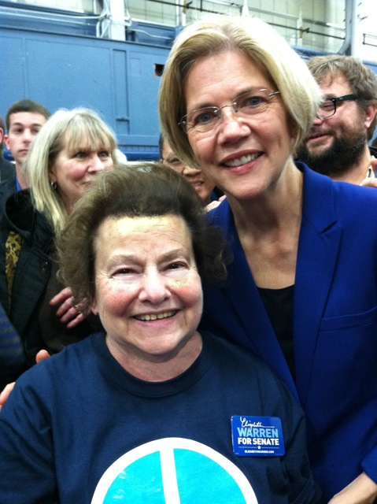
Our organization took a breath from our otherwise nonpartisan stance to recognize the reelection of President Obama and the shuffling of occupants in seats in the House of Representatives and the United States Senate.
We were pleased to note that Vermont’s Gov. Peter Shumlin was returned to office as was its Sen. Bernie Sanders. Senator Tammy Baldwin (WI) and Senator Elizabeth Warren (MA) are in our corner as are Congressmen Alan Grayson and John Conyers, both speakers at the September Progressive Democrats of America (PDA) gathering in Charlotte.
HCFA-SC founding member Ricky Ball worked tirelessly in the Boston area for Sen. Warren and now plans to send an “ask” letter for PNHP.

INSIDE - Members attended the Southern Anti-Racism Network (SARN) meeting in Mt Pleasant on November 11th. The gathering was principally to highlight SARN projects but our members did have the opportunity to interact with several activists. A quid pro quo offer was made by the SARN founder to align with HCFA-SC. This begs the question whether having a string of alliances on paper serves us or whether we should only affiliate with active partnerships.
We continue to be a presence on the PNHP national calls. This lets the folks in Chicago know we are making an effort and spurs us to accomplish so we will have news to report.

OUTSIDE - This is a quiet two months for us externally. As we get through the holiday season we expect to be formulating plans for events in the first quarter of 2013.

AMBASSADORS - Health Care for All – SC is pleased to announce that Dr. Emilio V. Perez-Jorge MD, FACP has accepted the post of Midlands Ambassador. Dr. Perez-Jorge is an Infectious Disease specialist with a practice in West Columbia in the central part of the state. We continue to seek members to represent Upstate, Pee Dee, and Low Country regions.

