October 2012

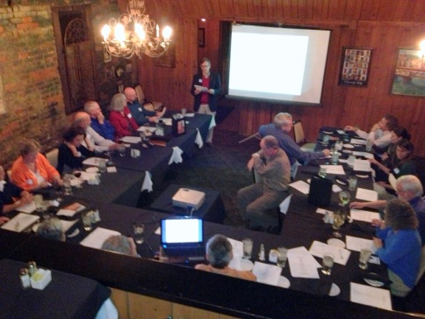
INSIDE – For our second meeting we met at Villa Tronco in Columbia. The October 17th meeting was well attended with a mix of returning members from the inaugural August event and newcomers including two medical students. The 22 attendees nicely filled the meeting space as we listened to a business focused presentation given by our NC sister chapter. The slideshow was given by Dr. John Johnston who made a persuasive case. A great deal of intelligent debate ensued (and the meal was good too). We found the meeting site excellent and may meet there again.

Attendees were polled as to whether we should try and have a third meeting before the holidays. The consensus was it would be better to pick up again after the 1st of the year. Our plan is to have HCFA-SC’s first public offering in the first quarter of 2013.

PNHP national began laying out a beta test website of Health Care for All – SC. It was unveiled at the October 17th meeting and was well received. We plan to use it as a repository for our efforts and a communication tool to members and those interested in learning more about Single Payer. It includes a petion that those that visit the site can show their support for Improved Medicare for All. We plan to post these monthly reports in the future.

OUTSIDE –Retiring Congressman Barney Frank (D-MA) sent a wonderful letter of encouragement. In part he wrote; “As simple as it may sound to you, my advice is that you organize as many people as you can to contact as many legislators as you can reach – and you have to reach them with people who live in their own districts.”

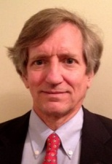
David Keely, HCFA-SC President, reached out to the South Carolina Christian Action Council (SCCAC) to establish an endorsement and partnership for specific advocacy of "Improved Medicare for All" via single-payer. The SCCAC is a statewide ecumenical partnership and it represents the "partnership of 16 denominations and 21 regional judicatories, including 4,500 congregations" [www.sccouncil.net]. Right now, the SCCAC has an ongoing focus on supporting the state Medicaid expansion called for by the federal Patient Protection and Affordable Care Act, and hopefully future HCFS-SC advocacy meetings with the SCCAC Board can result in single-payer system endorsement going forward.

Health Care for All – SC proud to announce first partnership
Oct 15, 2012
Swansea, SC
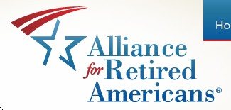
In her first official act as newly installed President of the South Carolina chapter of Alliance for Retired Americans (ARA) Donna Dewitt pledged a partnership with Health Care for All –SC (HCFA) to push for Single Payer health care reform. Citing the commitment both organizations share in strengthening Medicare. Dewitt expressed her strong support of HR 676.

Speaking on behalf of HCFA-SC was David S Ball, the Liaison to Physicians for a National Health Program (PNHP). “The only way to control spiraling health care costs, cover all Americans, and significantly improve the quality of medical care in this country is expand the highly successful Medicare program until it protects us all. Everybody in, nobody out.”

A number of groups were represented at the 2012 South Carolina ARA Convention. Leaders from the UAW Eastern Carolina Retiree Council, SC Progressive Network, and the Columbia chapter of the AFL-CIO as well as the state AFL-CIO were present. HCFA has been invited to address the Executive Board of the South Carolina AFL-CIO at its December meeting.

AMBASSADORS- Our “ask” at the October meeting for members to step up and commit as regional representatives has so far not been answered. A top tier goal at an upcoming meeting remains to get leaders for the four regions of the state – Upstate, Midlands, Pee Dee, and Low Country.

